普通高等学校设置国家控制的 高等职业教育（专科）专业申请表

**学校名称（盖章）：学校主管部门：**

**专业名称： 专业代码： 修业年限：**

**年拟招生人数： 申请时间：**

**专业负责人： 联系电话：**

中华人民共和国教育部制



学校基本情况表

|  |  |  |  |  |
| --- | --- | --- | --- | --- |
|  |  |  |  | |
|  |  |  |  | |
|  |  |  | □ □ □ | |
|  |  | |  |  |
|  |  | | | |
| 300 |  | | | |

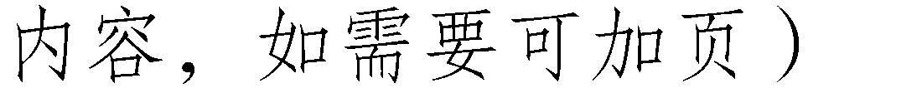申请增设专业的理由和基础



专业主要带头人简介

|  |  |  |  |  |  |  |  |  |  |  |  |  |  |  |
| --- | --- | --- | --- | --- | --- | --- | --- | --- | --- | --- | --- | --- | --- | --- |
|  |  | | |  |  | |  | |  | | |  | |  |
|  |  | |  | |  | | |  | |  |
|  | | | |  | | | | | | | | | | |
|  | | | |  | | | | | | | | | | |
|  | | | |  | | | | | | | | | | |
|  | | | |  | | | | | | | | | | |
|  | |  |  | | |  | | | | | | |  | |
| 1 |  | | |  | | | | | | |  | |
| 2 |  | | |  | | | | | | |  | |
| 3 |  | | |  | | | | | | |  | |
| 4 |  | | |  | | | | | | |  | |
| 5 |  | | |  | | | | | | |  | |
| 5 | |  |  | | |  | |  | |  |  | | |  |
| 1 |  | | |  | |  | |  |  | | |  |
| 2 |  | | |  | |  | |  |  | | |  |
| 3 |  | | |  | |  | |  |  | | |  |
| 4 |  | | |  | |  | |  |  | | |  |
| 5 |  | | |  | |  | |  |  | | |  |



教师基本情况表

|  |  |  |  |  |  |  |  |  |  |
| --- | --- | --- | --- | --- | --- | --- | --- | --- | --- |
|  |  |  |  |  |  |  |  | “  ” | / |
| 1 |  |  |  |  |  |  |  |  |  |
| 2 |  |  |  |  |  |  |  |  |  |
| 3 |  |  |  |  |  |  |  |  |  |
| 4 |  |  |  |  |  |  |  |  |  |
| 5 |  |  |  |  |  |  |  |  |  |
| 6 |  |  |  |  |  |  |  |  |  |
| 7 |  |  |  |  |  |  |  |  |  |
| 8 |  |  |  |  |  |  |  |  |  |
| 9 |  |  |  |  |  |  |  |  |  |



其他办学条件情况表

|  |  |  |  |  |  |  |  |
| --- | --- | --- | --- | --- | --- | --- | --- |
|  |  | | |  |  | | |
|  |  | | | | | | |
|  |  |  | / | | |  |  |
|  |  |  | | |  |  |
|  |  |  | | |  |  |
|  |  |  | | |  |  |
|  |  |  | | |  |  |
|  |  |  | | |  |  |
|  |  |  | | |  |  |
|  |  |  |  | | | / |  |
|  |  |  | | |  |  |
|  |  |  | | |  |  |
|  |  |  | | |  |  |

申请增设专业人才培养方案

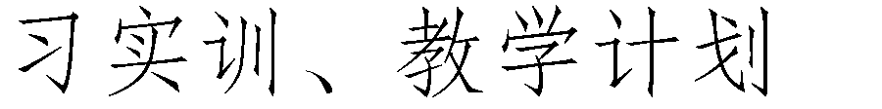

相关主管部门意见

|  |  |  |  |
| --- | --- | --- | --- |
|  |  |  |  |
|  |  |  |  |

注：省级行业主管部门意见可以函件形式附上，教育类专业须附省级教育行政部门负责教师工作处室意见。